Draft responses to NE Lincs

Everyone should read the SWOT analysis

2.2 Strengths and weaknesses
2.2.1 Preparing a local plan requires a sound understanding of the relationships between people and places considering the characteristics of place and how people live their lives. In so doing we can establish the strengths, weaknesses, opportunities and threats that will shape the policies and proposals set out in the Plan.
2.2.2 The tables below draw together information presented in a wide range of evidence, strategies and plans. Together they present a 'SWOT analysis' detailing the strengths and weaknesses, opportunities and threats, that exist within North East Lincolnshire.
Table 2.1 SWOT analysis (strengths and weaknesses)
Strengths | Weaknesses
- Economy: Strong and established industrial base, built on natural comparative advantage of Humber Estuary, bolstered by Freeport designation and transition to low carbon economy.  - Economy: National significance of five key sectors.  - Infrastructure: Including dock infrastructure, pipelines, road and rail freight infrastructure, and good standard of flood defences.  - Green Infrastructure: Internationally significant wildlife sites, AONB and open space and recreational facilities.  - Minerals: Resources include aggregates (sand and gravel), silica sand, and chalk(but no current extraction).  - Waste: Good record of sustainable waste management.  - Heritage: The heritage assets of the Borough contribute to the quality of places in which people want to live, work and invest. | - Demographics: An ageing population has implications for accommodation, healthcare and access to services for older people.  - Demographics: Areas of concentrated deprivation.  - Economy: low wage economy and weak levels of entrepreneurship.  - Economy: Lack of readily available and good quality sites and premises in suitable locations to match business needs.  - Economy: Large number of land hungry operations e.g. energy, storage and processing plants.  - Economy: Limited employment opportunities within the rural areas.  - Education: Low skills base a consequence of poor educational attainment.  - Housing: Lack of affordable housing delivery.  - Housing: Quality of the housing offer.  - Health and well-being: Home to some of the most deprived communities in England.  - Town centres: High vacancy levels, and lacking key facilities.  - Environment: Significant proportion of the urban area at high risk of flooding.  - Environment: Pockets of poor Air Quality.  - Environment: Below average tree canopy coverage.  - Transport: Car dependency and road congestion hotspots.  - Transport: Accessibility to employment for people with no car.  - Heritage: Number of buildings on the Heritage at Risk Register.

Table 2.2 SWOT analysis (opportunities and threats)
Opportunities | Threats
- Economy: Build on international significance of the ports and recent renewable energy related investments in the Humber.  - Economy: Niche development of the O&M market - builds on investment by Dong, Siemens, RWE etc.  - Economy: Ongoing role of the Ports within the UK import/export market. Capture the benefits of Freeport Zone.  - Economy: Links to the wider Lincolnshire agricultural economy to promote further innovation in food processing/food science and technology.  - Economy: SHIIP/Enterprise Zone designation provides opportunities to attract significant levels of business investment.  - Economy: Significant Levelling Up Funding supporting regeneration in Grimsby and Cleethorpes.  - Environment: Introduction of mandatory biodiversity net gain.  - Heritage: Assets provide opportunities for heritage led regeneration. particularly building on work at Grimsby Docks.  - Heritage: The historic environment can play a key role in helping to reinforce the distinct identity of the various parts of the Borough.  - Housing: Supply increased since local plan adoption. | - Demographics: Increasingly aged population and loss of economically active population presents a challenge for achieving suitable labour supply to meet growth aspirations.  - Education: Lack of higher education facilities and deficit of talented young people who leave to study elsewhere.  - Economy: Low value rents and land prices combine to impact upon commercial viability.  - Economy: Many key sectors facing significant rises in costs.  - Economy: Public sector finance cuts threaten public sector jobs and targeted public sector investment in areas of weakness.  - Economy: International competition for investment, especially in chemicals/processing and food processing sectors.  - Economy: Legislative change, especially at the European level placing restrictions on process industries and ports.  - Economy: Uncertainty of government policy with general election.  - Economy: Cost of Living squeeze reduces household expenditure Climate Change: Potential for stresses on habitats and species to increase.  - Climate Change: Increase in flood risk and severity of flood events.  - Housing: Low demand for housing in areas where there is greatest potential for employment related development.  - Housing: Weak viability limits opportunities on brownfield sites and inhibit affordable housing delivery.  - Housing: Development within strategic gaps eroding independence of village settlements.  - Heritage: Impact of new development upon the character of the Borough's historic assets and loss of assets through neglect and lack of investment.

3.1 Employment
3.1.1 Economic forecasts have been generated to assess the future growth that can be anticipated. this comprises:
- the Experian Baseline December 2022 projections which considers a net workforce jobs growth of 2,600 over the plan period 2022-2042; and,
- an alternative job-based projection based upon an assessment of additional job estimates generated by forthcoming Freeports proposals, carbon capture and renewables related developments, these proposals assuming the infrastructure projects and investment schemes would it is calculated potentially generate a net additional 1,960 jobs on top of the baseline Experian projection. This would result in a net increase of 4,560 jobs over the plan period.
3.1.2 The Experian Projection is produced by looking at past economic activity and combining this with predictions about future economic conditions, trends in the relevant sector and other internal and external factors.
3.1.3 The alternative jobs based projection is derived from an assessment of local future projects and investments aligned to national and local strategies, policies and investment proposals. This is sometimes referred to as a 'Policy-On' position. The following infrastructure projects and investment proposals have been identified aligned to key strategies and plans:
- Plans and strategies
  - Humber Freeport Zone (including infrastructure provision)
  - Grimsby Town Deal
  - South Humber Industrial Investment Programme (SHIIP)
- Key Projects
  - Humber Zero (Part of the zero carbon Humber vision involving hydrogen production) +200 jobs (excluding 2,500 temporary construction jobs);
  - Humber H2ub (Part of the zero carbon Humber vision involving hydrogen production +150 jobs;
  - Gigastack (Part of the zero carbon Humber vision involving wind energy/hydrogen production +180 jobs;
  - Immingham Green energy terminal (Hydrogen production) +1,000 jobs;
  - RWE Grimsby Wind Farm Hub (operations and maintenance) +60 jobs;
  - Orsted Wind Energy +250 jobs; and,
  - Hornsea Wind Energy +120 jobs.

Option 1

The Employment Requirement - Experian baseline 2022
Set the employment requirement aligned to the Experian Baseline 2022 Projection (net workforce jobs growth of 2,600 over the plan period 2022-2042).

Option 2

The Employment Requirement - 'Policy-On'
Set the employment requirement aligned to the 'Policy-On' position (net workforce jobs growth of 4,560 over the plan period 2022 to 2042).

Question 1

Employment requirement
To support the economic opportunities in the Borough, the Council is minded to support Option 2 ‘The Employment Requirement - 'Policy-On'’ aligned to maximising the opportunities for economic growth, the "Policy-On" position.
Do you have any comments?
The identified key projects may not provide employment exclusively within North East Lincolnshire. It would appear that consideration has not been given to the necessary infrastructure improvements or the potential demographic shifts that could come about as a result of the added employment opportunities.

3.2 Housing
3.2.1 The National Planning Policy Framework (NPPF), paragraph 61, states that:

"To determine the minimum number of homes needed, strategic policies should be informed by a local housing need assessment, conducted using the standard method in national planning guidance - unless exceptional circumstances justify an alternative approach which also reflects current and future demographic trends and market signals. In addition to the local housing need figure, any needs that cannot be met within neighbouring areas should be taken into account in establishing the amount of housing to be planned for".

3.2.2 The starting point is therefore to determine the local housing need using the standard method. (In August 2020 the Government consulted on changes to the standard method which looked at incorporating 2018-based projections and removing the cap that limits the level of local housing needs. The Government's response published in December 2020 confirmed that it would not be proceeding with the changes. As a consequence the 2014-based projections are used to inform the demographic starting point for the assessment of Local Housing Need). At present the standard methodology would result in a local need figure of 203. This is considered to be the minimum level of local housing need. According to the 2014-based SNPP, this would equate to a net change of 4,276 residents, 4,060 households but significantly a loss of 109 jobs over the 20 years 2022-2042. This is considered to be the baseline projection represented as Scenario A, in the Housing and Economic Development Needs Assessment (HEDNA 2023).
3.2.3 Based on the trends identified through the demographic and economic assessment of the Borough, a number of further scenarios have been considered to test whether any adjustment is required which deviates from the locally assessed need identified by the standard method.
3.2.4 The scenarios demonstrate the extent to which the population of the Borough could change over the Plan period and how this change would be translated into households, dwellings, numbers of economically active residents and the number of jobs that might be supported by the local population.
3.2.5 The number of households is translated into dwelling needs through the application of an assumption about the proportion of vacant properties/second homes that are currently recorded in the Borough.
3.2.6 The consultants, (Lichfields) preparing the Housing and Economic Development Needs Assessment (2023), modelled each of these scenarios using industry standard PopGroup demographic modelling software. Table 3.1 ‘Future Housing Scenarios (Total Growth 2022 to 2042 (Annual))’ below summaries the scenarios set out in the Assessment.

Table 3.1 Future Housing Scenarios (Total Growth 2022 to 2042 (Annual))
Scenario | Population Change | Households | Dwellings (annual in bold) | Jobs
Scenario A Standard Method | 4,276 | 3,870 | 4,060 (203) | - 109
Scenario B 2014-Based SNPP | 2,887 | 3,295 | 3,449 (172) | - 610
Scenario C 2014-based SNPP 2021 Census adjust | 2,309 | 3,533 | 3,698 (185) | - 1,900
Scenario D 2018-based SNPP | - 1,238 | 3,009 | 3,150 (158) | - 2,377
Scenario E 2018-based SNPP 2021 Census adjust | - 578 | 3,067 | 3,210 (161) | - 3,137
Scenario F Experian Baseline December 2022 | 11,114 | 7,920 | 8,292 (415) | + 2,600
Scenario G Experian 'Policy-On' | 15,231 | 9,695 | 10,150 (507) | +4,560
Scenario H Local Plan Housing Target | 15,514 | 9,781 | 10,240 (512) | + 4,755
Scenario I Past Housing Delivery | 6,388 | 5,980 | 6,260 (313) | +274

3.2.7 Scenarios D and E are based on the 2018 population projections, however, the Government has chosen not to adopt these projections as the basis of determining the minimum level of housing need for the assessment of Local Housing Need. Scenarios B, C, D and E all produce figures which are below that calculated by the standard method, and significantly below that represented by past housing delivery. As the standard method figure represents the minimum level of housing need these scenarios are not presented as options. Scenario H which represents the previous local plan target is similarly not represented as an option as the evidence upon which this scenario was based has now been superseded, and is included as the basis of comparison only.
3.2.8 This leaves four scenarios to be taken forward as options. It should be noted however, that the standard method calculation of Local Housing Need (LHN) is based on a projection of a decline of the working population. The HEDNA (2023) highlights that if unchecked this could have a serious negative impact on the local economy due to a declining labour force unless measures are implemented to increase the employment rate. It goes on to conclude; "given the strong regeneration and economic growth objectives being pursued by the Council this would suggest that the LHN generated by the Government's standard methodology is not appropriate for North East Lincolnshire moving forward".
3.2.9 It should also be noted that the past housing delivery scenario is based on the net delivery over the period 2013/14 to 2021/22. This includes a period before the local plan was adopted in 2018, and the period from 2018/19 to 2021/22 when the net figures recorded included an additional annual reduction of 45 to take account of the demolition of the Freeman Street flats. As the demolition of the flats formed part of a wider rationalisation of Lincolnshire Housing Partnership property portfolio to reduce vacancy levels it is considered that the allowance made may not be a true reflection of the need generated. As a consequence the 45 reduction may have been a greater allowance than was appropriate.

Option 3

Housing requirement - Scenario A standard method
This option would use the standard method to calculate a requirement for 203 dwellings per year and a loss of 109 jobs over the plan period.

Option 4

Housing requirement - Scenario I past housing delivery
This option is based on the past housing delivery figures for the Borough which would result in a requirement for 313 dwellings per year and a jobs growth of 274 over the plan period.

Option 5

Housing requirement - Scenario F Experian Baseline December 2022
This option would use the Experian Baseline (December 2022) which calculates a requirement for 415 dwellings per year and a jobs growth of 2,600 over the plan period.

Option 6

Housing requirement - Scenario G Experian 'Policy On'
This option would use the Experian 'policy on' scenario which calculates a requirement for 507 dwellings per year and a jobs growth of 4,560 over the plan period.

Question 2

Housing requirement
To support economic growth, the Council is minded to support Option 5 ‘Housing requirement - Scenario F Experian Baseline December 2022’ which would mean a requirement of 415 dwellings per annum and jobs growth of 2,600 over the plan period. (This option may require some flexibility to accommodate further growth).
Do you have any comments?
This scenario works on the assumption that all properties will be constructed solely within North East Lincolnshire. It is essential to take into account the number of houses planned or already under development in neighbouring parishes. Consideration must be given to the wider area to ensure sustainable growth thereby avoiding excessive overdevelopment that could lead to an over supply of new housing within North East Lincolnshire.

ADD COMMENT

Section 4 A vision for North East Lincolnshire
4.0.1 Section 2 ‘North East Lincolnshire in context’ sets out the range of issues that the Borough faces. They demonstrate a clear need for change, which serves as a strong indication that a 'business as usual approach to planning for the Borough's future is not one that should be considered appropriate.
4.0.2 Despite the challenges, the Borough is well positioned to maximise the potential of economic activity in key sectors. This economic growth is, essentially, a vehicle for change which, if planned for correctly, will improve the well-being of the community and revitalise towns and neighbourhoods. To achieve this, North East Lincolnshire must work alongside its neighbours to facilitate the real opportunities for change and growth that exists and maintain the Borough's distinctive role within the wider Humber Bank so that the growth is complementary to that in surrounding areas. Together with driving the economic priorities, the area's most valued assets must be protected and enhanced.
4.0.3 The Plan's vision remains, subject to some minor revisions, largely consistent with the vision in the existing local plan.

ADD COMMENT

4.1 The overall spatial vision

Spatial vision
By 2042 North East Lincolnshire will have built on its national and international recognition as a centre for offshore renewables, focusing on operations and maintenance and contributing significantly to the Humber's 'Energy Estuary' status. Growth in key sectors, food, energy, chemicals, ports and logistics, will be matched by a strong tourism and leisure offer. Evident through increased jobs and diversity of skills, the barriers to accessing jobs will have been broken down. This will be facilitated through the establishment of facilities to improve education and skills, and measures implemented to address housing need and affordability, and health and service needs, including countering deprivation issues in specific wards. A platform for sustained sustainable economic growth will have been created, with conditions to capture and sustain more and better jobs in the area well established. Town centres will be successful, having widened their offer to the communities they serve.
Environmental quality will be an established source of pride, aspiration and confidence. The special character, biodiversity and distinctiveness of the Borough will continue to be protected and enhanced. The Borough's ecological and green infrastructure networks will have been improved, providing improved habitats and access to nature for local communities. A commitment will have been demonstrated, to address the causes and consequences of climate change, including bringing about an overall reduction in the proportion of properties at risk from flooding.
Good progress will have been made to make North East Lincolnshire a forward looking Borough where aspirations have been raised, and gaps narrowed in terms of social inequality; whether caused by health, education, age, disability, ethnicity, location or other aspects. Housing initiatives will have successfully revitalised areas of low housing demand, and steps taken to lift housing delivery to support economic growth, recognising the need to provide housing to address demographic change, and meet the prospects for economic growth over the plan period and beyond; whilst providing choice within the housing market, and being sensitive to the scale and character of settlements.

Question 3

Spatial vision
Do you agree that the vision, as set out above, is appropriate to be taken forward in the Local Plan?
No comments to add.

4.3 Strategic objectives
4.3.1 The objectives set out below relate directly to the spatial vision. They provide a framework for the local plan policies to facilitate the form and pattern of development necessary to ensure that the vision is fully realised by 2042. The objectives are mutually supportive and are not listed in order of priority. The objectives remain unaltered from the existing local plan.
4.3.2 Appendix A ‘Strategic objectives and policy relationship’ demonstrates which objective(s) each policy in the Plan is working towards.

SO1 Population
Meet development needs and facilitate economic development by supporting population growth, retaining working age population and providing for a generally ageing population.

SO2 Climate change
Address the causes and effects of climate change by promoting development that minimises natural resource and energy use; reduces waste and encourages recycling; reduces pollution; brings about opportunities for sustainable transport use; responds to increasing flood risk; and, incorporates sustainable construction practices. Promote appropriate distribution of development and the role of green infrastructure in mitigating aspects of flood risk. Recognise the increased stress on habitats and species that climate change causes.

SO3 Economy
Support environmentally responsive local economic growth by promoting conditions that sustain an increase in the number of better paid jobs; and, raising skills. Promote rural regeneration and diversification, including a strengthened tourism offer.

SO4 Housing
Significantly boost housing supply to meet the existing and future housing needs of the whole community. High quality market and affordable housing, specific provision for the elderly, special needs housing and gypsy ad travellers accommodation will be supported. A balanced supply of deliverable sites will be identified to achieve as a minimum, the objectively assessed needs of the Borough.

SO5 Social and health inequality
Narrow the gap in terms of social and health inequality by addressing issues of housing choice, providing accessible employment and training opportunities, promoting healthier lifestyles, providing healthcare and community facilities, improving educational attainment and cultural facilities; and establishing protecting and maintaining a network of accessible good quality open space, sport and recreation facilities.

SO6 Built, historic and natural environment
Ensure that the development needs of the Borough are met in a way that safeguards and enhances the quality of the built, historic and natural environment and ensures that the development needs are met in a way that minimises harm to them. Direct development to locations of least environmental value and proactively manage development to deliver net gains in biodiversity overall. Encourage the use of brownfield land.

SO7 Transport
Improve accessibility to jobs and services by sustainable transport modes, including cycling and walking; reduce the overall need to travel with employment and housing growth spatially balanced; and, provide the necessary infrastructure to support sustainable growth.

SO8 Town centres and local facilities
Strengthen the vitality and viability of town centres, meeting the needs for retail, commercial and leisure uses, focusing appropriate uses on town centre sites, promote regeneration where appropriate and support the retention of local community and service facilities.

SO9 Design
Raise the quality of developments by applying the principles of goo sustainable and inclusive design; promote safe, secure and accessible streets and places; and, recognised the importance of supporting and strengthening local character and distinctiveness.

SO10 Minerals and Waste
Safeguard important mineral resources and support minerals infrastructure for the future. Promote the application waste hierarchy in the management of waste and deliver sustainable facilities to manage waste.

Question 4

Strategic objectives
Do you agree that the objectives are appropriate to be taken forward in the local plan?
No comments to add to this.

5.1 Hierarchy
5.1.1 The settlement hierarchy is one of the key factors which influences and underpins the spatial distribution of future development. Broadly speaking, it is a factor which should be taken into account when assessing the amount of development appropriate in different settlements and areas of the Borough. A settlement that sits higher in the hierarchy would, in principle, be expected to accommodate a higher level of growth.
5.1.2 Draft Strategic Policy 1 ‘Settlement hierarchy’ is informed by the spatial portrait set out in 2.1 ‘Portrait’, and the more detailed Settlement Accessibility Assessment (2023). The detailed assessment is founded on an objective approach which uses a number of key indicators to assign points to settlements. The settlements which accumulate the highest number of points are deemed to be those which provide the greatest level of accessibility for residents to a wide range of key services and amenities, including education, healthcare and recreation.
5.1.3 The defined settlement hierarchy in Draft Strategic Policy 1 ‘Settlement hierarchy’ establishes four levels of settlement. This hierarchy should be considered alongside key development needs and constraints, infrastructure capacity and the availability of land for development. The Council is considering revising the existing policy to strengthen the approach to prevent coalescence of the 'Arc settlements' and therefore maintain their individual identities.

Draft Strategic Policy 1

Settlement hierarchy
- The following settlement hierarchy will provide the framework for the Council's decisions on the location and scale of development and on investment in services and facilities. Development should be commensurate with a settlement's position in the settlement hierarchy.
Table 5.1 Defined settlement hierarchy
Level | Settlements
Level 1  Urban Area | Relates to the urban area of Grimsby and Cleethorpes, including the adjoining parish of Great Coates which functions as one entity, albeit with a different character.  The urban area provides the greatest accessibility to key services and amenities and has historically delivered the greatest number of new homes. Future development of this area would involve brownfield and greenfield sites, including land adjacent to and beyond the settlement edge. Such development is regarded as sustainable where access to services and amenities is good or can be provided.
Level 2  Local Service Centres | Relates to the stand alone town of Immingham and the 'Arc Settlements' of Healing, Humberston, Laceby, New Waltham and Waltham.  These settlements perform the role of key local service centres offering a good range of basic services and amenities, combined with good accessibility to the wider services available in the urban area. Future development would involve development principally of greenfield sites adjacent to but within the defined settlement development area boundary, with an emphasis on preventing coalescence and maintaining the individual identity of settlements.
Level 3  Rural Settlements | Relates to the rural settlements of Habrough and Stallingborough.  These rural settlements offer a much lower provision of services but do offer good accessibility to higher level settlements. Future development would involve smaller scale development principally limited to infill sites within or sites within but immediately adjacent to the defined settlement development area boundary.
Level 4  Minor Rural Settlements | Relates to the minor settlements of Ashby cum Fenby, Aylesby, Barnoldby le Beck, Beelsby, Bradley, Brigsley, Hatcliffe, Hawerby cum Beesby, Irby upon Humber, East and West Ravendale, and Wold Newton.  These small rural settlements offer very few services and amenities and poor accessibility to higher level settlements. Future development would involve only limited infill, conversion and re-use of existing buildings with very limited further development.

Question 5

Settlement hierarchy
The policy has been revised, relating to Level 2 settlements, to include text to strengthen the approach to prevent coalescence of the 'Arc' settlements therefore maintaining their individual identities.
Do you have any comments?
How will neighbouring parishes such as Holton le Clay, North Thoresby and Tetney be included in the settlement hierarchy?

5.2 Growth and distribution
5.2.1 New housing will be distributed in relation to the spatial strategy. This should reflect Draft Strategic Policy 1 ‘Settlement hierarchy’, locations of existing employment clusters, development constraints, accessibility and service provision. It should specifically sets out what level of residential development will be commensurate with individual settlements.
5.2.2 The Draft Plan presents options on the spatial distribution which will affect the proportion of development to be delivered in each of the spatial zones. In selecting your preferred option you should consider specifically;
- the need to fulfil the housing needs requirements over the plan period and beyond;
- the need to provide choice in the housing market;
- the need to reconcile competing housing market pressures with the drive to promote sustainable transport choices;
- the need to balance development pressures with the need to prevent coalescence of settlements;
- the desire to regenerate brownfield sites with the need to provide sufficient deliverable housing sites to meet future housing needs which necessitates large area of greenfield development;
- the need to regenerate and redevelop urban areas to address specific issues of inequality and deprivation, set against consideration of flood risk in these areas;
- the need to foster and support economic growth, recognising the locational preferences and requirements of key sectors; and,
- the provision of community facilities and services, including schools and healthcare.
5.2.3 A number of spatial options are set out below which have different implications for the amount of development to be delivered in the different settlements across the borough. For all of the options there is a emphasis on maximising delivery from brownfield sites where this is achievable. (The Council prepares a register of brownfield sites on an annual basis which provides details of known sites which are available for development). Each of the options is accompanied by an explanation of the implications of the approach.

Statement 2

Sites under construction
The spatial strategy will need to recognise the status of sites that are under construction or that have gained planning consent. As the local plan will take some time to reach adoption it is likely that the status of some sites will change over this time and will need to be captured as time passes.

Option 7

Urban focus including strategic urban extensions
This option would see development focused on the urban areas of Grimsby Cleethorpes and Immingham, with less growth in the arc villages and rural settlements. This option would see development of the Grimsby West and Humberston Road strategic urban extensions.
Table 5.3 Advantages and disadvantages to Option 7
Advantages | Disadvantages
This option directs most development to urban centres which offer the best accessibility to services and public transport. This option includes the strategic urban extensions where homes can be delivered together with supporting infrastructure, services and recreation and open space. It also focuses development in closes association and accessibility to the Humber employment zone. | This option would see a constraint on locations that have been favoured by the housing market, which may lead to under delivery.

Option 8

Greater Arc growth, excluding strategic urban extensions
This option would see more growth in the arc villages of Humberston, New Waltham, Waltham Laceby and Healing with a relaxation of the restraint on growth in the gaps between settlements.
Table 5.4 Advantages and disadvantages to Option 8
Advantages | Disadvantages
This option delivers more housing in the locations favoured by the housing market. | This option would see more development in the gaps between the arc settlements and more pressure on existing services, for example health and schools and the transport network.

Option 9

Arc constraints including strategic urban extensions and urban focus
This option would see a strengthening of the policy of restraint relating to the arc settlements and safeguarding the gaps between settlements. This option would see development of the Grimsby West and Humberston Road strategic urban extensions.
Table 5.5 Advantages and disadvantages to Option 9
Advantages | Disadvantages
This option maintains and strengthens the independence of settlements and safeguards the green areas between them, whilst promoting urban development including strategic urban extensions where homes can be delivered together with supporting infrastructure, services and, recreation and open space, and strategically close to the employment zone. | This option would see a constraint on locations that have been favoured by the housing market.

Option 10

Wider distribution excluding strategic urban extensions
This option would see a wider relaxation of the policy of restraint, seeing a wider distribution of development with more development in the smaller settlements.
Table 5.6 Advantages and disadvantages to Option 10
Advantages | Disadvantages
This option maximises the range, type, and location of sites across the Borough. | This option would see more development in locations lacking in services and infrastructure and represents the least sustainable option.

Note
- Under all options: brownfield sites where there is evidence that development is viable and achievable will be given priority through the site selection process.
- Sites under construction are committed and are therefore not subject to review, this currently accounts for the future delivery of 3,406 homes.

Question 6

Distribution of growth
Taking account of the advantages and disadvantages of the identified options, the Council is minded to support Option 9 ‘Arc constraints including strategic urban extensions and urban focus’.
Do you have any comments?
The parish council would appreciate greater focus on the development of the A180 corridor due its excellent transport links. The A16 is already strained by current traffic volumes, making additional development unsustainable. As the A180 corridor is where it is envisaged the bulk of new industrial development and employment growth will be, it appears logical that housing development should also focus on that side of North East Lincolnshire. This would help with alleviating commuting times and traffic congestion in Grimsby by minimising the need for travel through the area.

ADD COMMENT

5.3 Development boundaries
5.3.1 Development boundaries distinguish between built-up areas and areas of open countryside. The use of development boundaries in planning has been successful in indicating clearly the locations where development will usually be acceptable, subject to meeting normal development management criteria. It is an approach that has, in the past, been strongly supported in North East Lincolnshire and continues to be supported today.
5.3.2 The development boundaries will be identified on the Policies Map. These boundaries will take account of housing allocations when they are confirmed. Where it is known that developments will incorporate extensive areas of perimeter landscaping at the edge of settlements, the development boundaries will been drawn to follow the extent of the built-up development.
5.3.3 A number of considerations will inform the final process of defining the development boundaries, including the nature and form of settlement edges, and an assessment of the landscape sensitivities; this includes:
- considering whether settlements include key characteristics or distinctive features which contribute to their sense of place;
- identifying features that define current settlement edges and determining whether they are strong or weak; and,
- assessing opportunities for enhancement through identification of approaches and views, distinctive features, visual open space and sensitivity to change.
Table 5.7 Key aspects considered in defining development boundaries
The need for new development | Ensuring that sufficient sites are available to accommodate future requirements by incorporating sites that:  - contribute to the supply of housing (allocated sites); and,  - contribute to the supply of employment land.  Boundaries are not drawn so tightly to exclude all new development; they are influenced by the physical features that define the settlement edge and will provide some opportunities for small scale development above and beyond allocated sites.
The setting of the settlement | Considering the particular landscape and surrounding countryside features in the vicinity of the settlement edge:  - recreation and amenity open space (including school playing fields), which is physically surrounded by the settlement or adjoining settlement on three sides, is included within the boundary; and,  - recreation or amenity open space that extends into the countryside or primarily relates to the countryside, is excluded from the boundary.
The existing form, character and pattern of development | Considering the impact of further development on the existing development pattern. Ensuring boundaries are not contiguous if the form of the settlement does not reflect this. If the settlement is characterised by small groups this is reflected in the boundaries.  The defined boundaries are not drawn so as to 'round off' or 'straighten' edges as this would be contrary to an approach that seeks to safeguard local character and distinctiveness, as it is often the irregularity of settlement edges that adds to a settlement's attractiveness.
Preventing coalescence of settlements | Boundaries include the gardens (curtilage) of properties except where they are functionally separate from the dwelling or, where the scale of the site is such that it could, through future development, lead to ribbon development or coalescence with a nearby settlement.
The presence of physical boundaries | Recognising that natural or man made features such as rivers, woodlands, or roads and railways can form logical defining boundaries. However, areas of caravan, chalet and other temporary accommodation are excluded from the defined boundary reflecting their temporary status.
Minimising impacts on the character of open countryside | Boundaries ensure the intrinsic character and beauty of the countryside is respected, with particular consideration given to the Lincolnshire Wolds Area of Outstanding Natural Beauty designation.
Avoiding ribbon or scattered development | Ensuring that development does not creep along road frontages into open areas, or result in scattered development unrelated to existing development form.  Freestanding buildings, individual and small groups of dwellings, including farm buildings which are detached or peripheral to the main built-up area of the settlement are excluded from boundaries.
Minimising impacts on heritage and biodiversity value | Ensuring that sites of heritage or biodiversity value are identified and not put at risk.
The presence of HSE consultation zones | Recognising that development opportunities may be limited or restricted in specific areas.
Traffic noise | Based on current assessments of noise, boundaries exclude areas where it is known that road surface noise impacts on living conditions.
Accessibility to services and facilities | Boundaries reflect the findings of the Settlement Accessibility Assessment (2023).

5.3.4 Draft Strategic Policy 2 ‘Development boundaries’ outlines the generic considerations that will be applied when considering all development proposals, (within development areas, within development boundaries; and within open countryside, outside development boundaries). They reflect core principles and considerations set out in National Planning Policy. These generic considerations provide the basis for considering whether the development proposed should be supported and approved.
5.3.5 Draft Strategic Policy 2 ‘Development boundaries’ specifically allows for development sites and opportunities to be identified and defined through the neighbourhood planning process. In some cases, where the local community decides that this is appropriate, a neighbourhood plan will effectively amend identified development boundaries.
5.3.6 The Policy establishes the nature of development that would be supported and approved, both within, and beyond the development boundaries, setting out the key considerations and criteria that would apply. Minor changes to the existing development boundaries policy are proposed to provide clarity on development allowed outside development boundaries.

Draft Strategic Policy 2

Development boundaries
- Development boundaries will be identified on the Policies Map. All development proposals located within or outside of the defined boundaries will be considered with regard to suitability and sustainability, having regard to:
  - the size, scale, and density of the proposed development;
  - access and traffic generation;
  - provision of services (education, healthcare, community, retail and recreation);
  - impact upon neighbouring land uses by reason of noise, air quality, disturbance or visual intrusion;
  - advice from the Health and Safety Executive;
  - flood risk;
  - the quality of agricultural land;
  - measures to address any contamination of the site; and,
  - impact on areas of heritage, landscape, biodiversity and geodiversity value, including open land that contributes to settlement character.
- Development proposals located within but adjacent to defined boundaries will be permitted where schemes respond to:
  - the nature and form of the settlement edge;
  - the relationship between countryside and the settlement built-form; and,
  - opportunities to contribute to the network of green infrastructure.
- Beyond the development boundaries land will be regarded as open countryside. Development will be supported where it is in harmony with the local setting and recognises the distinctive open character, landscape quality and role these areas play in providing the individual settings for independent settlements, and specifically;

  - supports a prosperous rural economy, particularly where it promotes the development and diversification of agricultural and other land based rural businesses; or,
  - promotes the retention and development of local services and community facilities; or,
  - supports rural leisure and tourism developments, including the creation of holiday accommodation; or,
  - consists of affordable housing to meet specific local needs; or,
  - is development that has been specifically defined and identified through the neighbourhood planning process; or,
  - it consists of the conversion of an existing building (where the existing building is integral to the conversion).

Question 7

Development boundaries
Revisions to the Development Boundaries policy are proposed to provide clarity on the development related to conversion of buildings allowed outside the boundaries, criteria F.
Do you have any comments?

No comments to add to this.

5.4 Green wedges
5.4.1 The introduction of a 'Green Wedges' policy is being considered. A number of settlements in the Borough have seen rapid expansion since the Local Plan was adopted and seen further development pressures particularly during the period of speculative planning applications when the Council could not demonstrate a five year housing land supply. This has put considerable pressure on the open land that forms the existing strategic gaps between settlements.
5.4.2 Whilst the existing Local Plan, Policy 40 Developing a green infrastructure network, affords some protection to the gaps between settlements it does not define edges to the protected areas. It is considered appropriate to explore the potential of strengthening the protection given to specific areas of land that are considered crucial in maintaining the individual character and setting of the settlements, provide important ecological corridors and promote the establishment of networks of green space. Policy 40 previously identified strategic gaps in the following broad locations:
- Immingham and industrial development to the north;
- Stallingborough and Healing;
- Healing and Grimsby;
- Laceby and Grimsby;
- Waltham and Grimsby and New Waltham;
- New Waltham and Grimsby and Humberston; and,
- Humberston and Cleethorpes.
5.4.3 The purpose of the proposed Green Wedges Policy would be to provide greater protection to the open and undeveloped character of areas within them, maintain and strengthen the independence and identity of individual settlements. The Council is also keen to increase the biodiversity within these areas and support the strengthening of natural networks. It would therefore specifically support proposals to create biodiversity net gain sites or other approaches to enhance the natural environment in these areas.
5.4.4 Whilst the aim would be to strengthen the landscape quality and environmental quality of these areas, it would not be intended that they should operate as an absolute restriction on all development proposals. Due to their multi-functional role, there are also various ‘non-open space’ uses that already exist and essential infrastructure that may be required. As such, certain types of development may be acceptable, as long as they are not detrimental to the character, role and function of the Green Wedge within which they are situated. This may include agricultural and forestry related development, green space, outdoor sport and recreation uses or the reuse of rural buildings and extensions or alterations to existing dwellings. It may also include flood defence or drainage works, provision of new infrastructure such as bridges or telecommunications, or specific development required by a public or private utility to fulfil their statutory obligation.
5.4.5 If taken forward it is intended that the Green Wedges Policy would apply to land which has initially been assessed as meeting the criteria for identification.

Statement 3

Identification of green wedge areas
The final identification of the boundaries to the green wedge areas will need to be reconsidered in light of the housing requirement, the spatial approach to be taken forward; and the final selection of development sites.

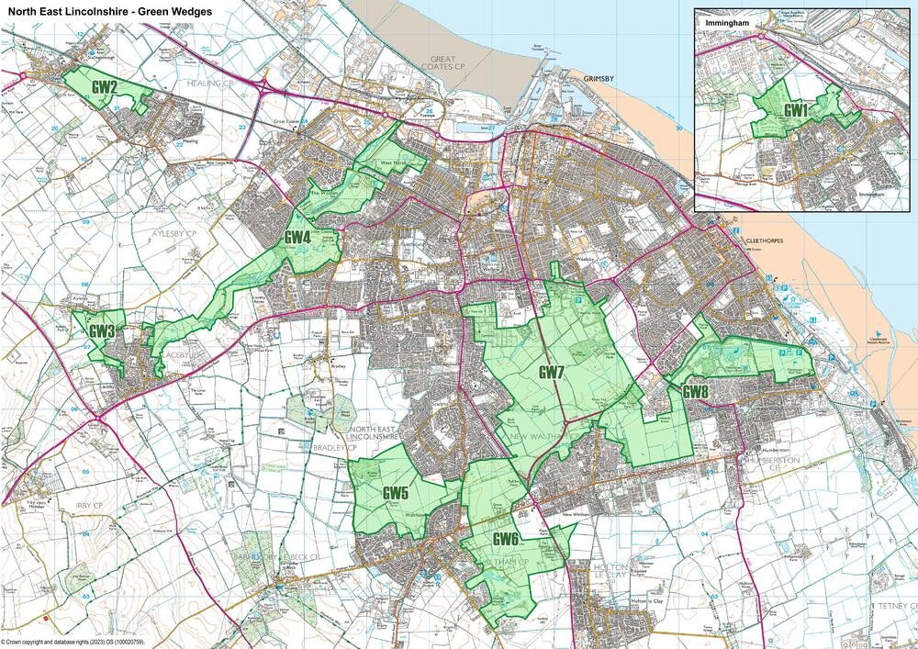
Figure 5.1 Proposed Green Wedge Areas

Draft Strategic Policy 3

Green wedges
- Green Wedges, as identified, have been identified to fulfil one or more of the following functions and policy aims:
  - prevention of the physical merging of settlements, preserving their separate identity, local character and historic character, or provision of a buffer between non-compatible uses;
  - provision of an accessible recreational resource, with both formal and informal opportunities, close to where people live, where public access is maximised without compromising the integrity of the Green Wedge;
  - creation of a multi-functional ‘green lung’ to offer communities a direct and continuous link to the open countryside beyond the urban area;
  - conservation and enhancement of local wildlife and protection of links between wildlife sites to support wildlife corridors, including provision of biodiversity net gain sites.
- Within the Green Wedges planning permission will not be granted for any form of development, including change of use, unless:
  - it can be demonstrated that the development is not contrary or detrimental to the above functions and aims; or,
  - it is essential for the proposed development to be located within the Green Wedge, and the benefits of which override the potential impact on the Green Wedge. (It may include flood defence or drainage works, provision of new infrastructure such as bridges or telecommunications, or specific development required by a public or private utility to fulfil their statutory obligation).
- Development proposals within a Green Wedge will be expected to have regard to:
  - the need to retain the open and undeveloped character of the Green Wedge, physical separation between settlements, historic environment character and green infrastructure value;
  - the maintenance and enhancement of the network of footpaths, cycleways and bridleways, and their links to the countryside, to retain and enhance public access, where appropriate to the role and function of the Green Wedge; and,
  - opportunities to improve the quality and function of green and blue infrastructure within the Green Wedge with regard to the green infrastructure network and Biodiversity Opportunity Mapping.
- Development proposals adjacent to the Green Wedges will be expected to demonstrate that:
  - they do not adversely impact on the reasoning for the designation of the Green Wedge, taking into account scale, siting, layout, design, materials and landscape treatment; and,
  - they have considered linkages to and enhancements of the adjacent Green Wedge.

Question 8

Green wedges
Do you have any comments about the proposed introduction of a Green Wedges policy, or the wording of the Green Wedges policy as set out?
The Parish Council disagrees with items 2(a) and 2 (b) due to the overall nature and definition of a Green Wedge. The provision of items 2 (a) and 2 (b) within the Draft Strategic Policy allows for too much ambiguity, potentially enabling development to occur and going against the whole purpose of the Green Wedge policy.

Question 9

Green wedges
Do you have any comments about the proposed areas identified for consideration of specific protection as a Green Wedge?

The designated area marked as GW6 on the plan should be extended further to the south – west of Holton le Clay to cover the whole part of the airfield that falls within the boundaries of North East Lincolnshire.

Draft Strategic Policy 4

Infrastructure
- The Council will support developments to create, expand or alter service facilities, including schools, health facilities and key infrastructure to meet the needs of existing and new communities.
- The Council will work with developers and partner organisations to ensure the delivery of infrastructure, services and community facilities necessary to develop and maintain sustainable communities; and will require provision of infrastructure and infrastructure improvements which are necessary to make development acceptable to be delivered in association with those developments. These improvements will where appropriate be secured by planning condition, obligations or levy charges as appropriate.
- Proposals for telecommunications development, including consideration of appropriate prior approval applications will be permitted, or determined, provided that:
  - the development is appropriate in terms of siting and appearance, having regard to technical and operational constraints, and does not intrude into or detract from the landscape or urban character of of the area with specific regard to the setting and beauty of the AONB;
  - applicants demonstrate a sequential approach to show that development cannot be accommodated with less visual intrusion:
    - on an existing building, mast of other structure, or;
    - on a site that already contains telecommunications equipment before new sites can be considered;
    - adequate screening and/or landscape measures are included, and;
    - provision is made for the removal of the facilities and reinstatement of the site as soon as reasonably practicable after it is no longer required for telecommunication purposes.
- Contributions towards infrastructure will be based on the demands created y the specific development. This includes provision of new, or enhancement of the existing infrastructure and facilities, including, but not necessarily limited to:
  - physical infrastructure, including:
    - transport improvements, including highways, public transport, provision for cyclists and pedestrians;
    - drainage and surface water management (including SuDs maintenance where appropriate); and,
    - flood defences (where site specific requirements warrant such an approach).
  - social infrastructure, including:
    - affordable housing; and,
    - education, including primary and secondary and SEN (special education needs) provision of; one primary pupil/four dwellings, one secondary pupil/five dwellings and 0.5 SEN pupil included for every 5.5 primary pupil places generated. (Pupil generation is based upon pupil generation ratios, as set out in the Education Justification Statement (2023).) The threshold at which contributions will be sought is ten units for primary and secondary and 24 units for SEN [i.e. 24 dwellings would generate a requirement for 0.5 SEN and 5,5 primary], excluding dwelling exclusively for over 55s, care homes, extra care, affordable homes and one-bed accommodation.
  - green infrastructure, including:
    - green space, sport recreation and play space, including future maintenance;
    - habitat mitigation provision and maintenance, particularly in association with South Humber Bank employment sites; and,
    - Biodiversity Net Gain.
  - Existing infrastructure will be safeguarded, except where there is clear evidence that particular infrastructure is no longer required to meet current or future needs, or can be delivered through alternative provisions.
  - Where financial contributions are made, and in the event it is found that they exceed the cost of necessary works or the contributions remains unspent after an agreed period of time, the contributions will be returned, in part of entirely, as may be appropriate.
  - The Council will in addition support:
    - proposals that deliver health infrastructure including doctor's surgeries and pharmacies, which offers improved services for their users; and,
    - applications made by the emergency services which will deliver improved services for their users.
  - The Council will seek to ensure that all development is commercially viable and deliverable. Where the delivery of a proposed scheme is threatened on the basis of viability, the Council may consider a reduction in the extent of the obligations required to submit a detailed Financial Viability Assessment on an 'open book' basis, and in sufficient detail in order to justify any reduction from the expected requirements of the scheme. All such submissions, where required by the Council, should provide sufficient information to enable an independent assessment to be undertaken. As a minimum, this should be in accordance with the guidance on such content set out within RICS Guidance Note GN2012/94 Appendix C. All submissions will be subject to an independent assessment prior to the determination of the application.

Question 10

Infrastructure
Revisions to the infrastructure policy are proposed, to include contributions towards SEN (special education needs) provision and take account of the mandatory introduction of biodiversity net gain; and incorporate telecommunications?
Do you have any comments?
Greater emphasis should be placed on Biodiversity Net Gain in accordance with the Town and Country Planning Act 1990. In terms of infrastructure development, this policy should also include development of public transport, access to medical facilities and the provision of inclusive education for students of all abilities.

Draft Strategic Policy 5

Flood risk
- Development proposals should have regard to the requirements of the flood risk sequential test and, if necessary, the exception test. The regeneration benefits of development in areas of high flood risk should also be considered in light of the Council's Guidance Note on the application of the Sequential and Exception Tests in North East Lincolnshire, and the Environment Agency's Standing Advice.
- In order to minimise flood risk impacts and mitigate against the likely effects of climate change, development proposals should demonstrate that:
  - where appropriate, a site specific flood risk assessment has been undertaken, which takes account of the best available information related to all potential forms of flooding;
  - there is no unacceptable increased risk of flooding to the development site or to existing properties;
  - the development will be safe during its lifetime;
  - Sustainable Drainage Systems (SuDs) have been incorporated into the development unless their use has been deemed, and accepted by the Council as inappropriate;
  - opportunities to provide natural flood management and mitigation through green infrastructure have been assessed and justified, based upon sound evidence, and, where appropriate, incorporated, particularly in combination with delivery of other aspects of green infrastructure in an integrated approach across the site;
  - arrangements for the adoption, maintenance and management of any mitigation measures have been established and the necessary agreements are in place;
  - access to any watercourse or flood defence asset for maintenance, clearance, repair or replacement is not adversely affected; and,
  - the restoration, improvement or provision of additional flood defence infrastructure represents an appropriate response to local flood risk, and does not conflict with other Local Plan policies.
- Sites fronting the sea wall defences between the ports of Immingham and Grimsby should specifically ensure that a 15metre buffer is maintained clear of development from the toe of the existing defences, so as not to prejudice future heightening of the existing sea wall defences.

Question 11

Flood risk
Revisions to the flood risk policy are proposed to safeguard land for future flood defence works.
Do you have any comments?

No comments to add.

Question 12

Water management
No change to the water management policy is proposed.
Do you have any comments?

No comments to add.

Question 13

Low carbon energy
Revisions to the Low Carbon Energy policy are proposed to include refence to the net zero targets, and introduce an expectation on development of large scale commercial solar or onshore wind to demonstrate a benefit to local communities in the locality.
Do you have any comments?

No comments to add.

Question 14

Energy and low carbon living
Revisions to the energy and low carbon living policy to require the incorporation of energy efficiency and low carbon technology as a specific consideration of the design stage.
Do you have any comments?

No comments to add.

Question 15

Health and wellbeing
Do you have any comments about the introduction and wording of the Health and Wellbeing policy?

No comments to add.

Draft Strategic Policy 9

Developing a green infrastructure network
- Development will be expected to maintain and improve the network of green infrastructure. Appropriate opportunities should be taken to improve the overall connectivity of green spaces, including improvements to access to the countryside and permeability of the urban area, for pedestrians, cyclists and horse riders. Recognition should also be made to the role such green infrastructure plays in mitigating the effects of recreational pressure on the Humber Estuary SAC/SPA/Ramsar, specifically designing natural green space which is attractive to walkers and dog walkers, particularly in areas where development is most likely to result in increasing visitors to the Humber Estuary SCA/SPA/Ramsar.
- Proposals that would result in the loss or reduction in quality or existing public rights of way (PROWs) will not be permitted unless acceptable equivalent alternative provision is made. Where diversions are proposed, these should be convenient and attractive to users and not increase disturbance on protected wildlife sites.
- The multiple value and functionality of green space should be recognised in the planning, design and implementation of developments, and particular attention should be given to planning positively for biodiversity and sustainable water management, including climate change mitigation, when considering the layout of development and delivery of biodiversity net gain proposals. The broad areas defined as strategic green infrastructure corridors are favoured locations for delivery of off-site biodiversity net gain sites.
- In pursuance of a principle of developing a green infrastructure network the Council will protect the setting and separate identity of settlements; require buffers between potentially conflicting uses; prevent coalescence of settlements; retain the openness of land; control the nature and scale of urban and rural development; and seek to improve the quality of the green infrastructure. Specific emphasis will be afforded to the open areas between:
  - Immingham and industrial development to the north;
  - Stallingborough and Healing;
  - Healing and Grimsby;
  - Laceby and Grimsby;
  - Waltham and Grimsby and New Waltham;
  - New Waltham and Holton-le-Clay;
  - New Waltham and Grimsby and Humberston; and,
  - Humberston and Cleethorpes.
- These predominantly open areas of green space link with areas of formal and informal green space to form strategic green infrastructure corridors, the framework of which will be identified on the Policies Map.
- Development adjacent to defined development boundaries should pay particular regard to the nature and form of green infrastructure at or in proximity to the settlement edge. Where possible and where appropriate, development should contribute to enhancing the network of green infrastructure, respecting the relationship between countryside and the settlement built form, particularly avoiding hard settlement edges.

Question 16

Green infrastructure networks
Revisions to the green infrastructure policy are proposed to emphasise the development and enhancement of a network of green space, building on existing assets and enhancing the overall quality of the environment. The open gap between New Waltham and Holton Le Clay has also been added to the areas offered specific protection.
Do you have any comments?
Preserving the open gap between New Waltham and Holton le Clay is essential to prevent the merging of the villages and to maintain their individual identities.

Draft Strategic Policy 10

Landscape
- Landscape character should be given due consideration in the nature, location, design and implementation of development proposals. Developers should:
  - have regard to the landscape context and type within which the development is to be located, (as identified in the Landscape Character Assessment); considering the landscape guidelines and management strategies relevant to the prevalent landscape type. Priority will be given to the protection and enhancement of the landscape character and natural beauty, and setting of the Lincolnshire Wolds Area of Outstanding Natural Beauty (AONB);
  - complete a site specific landscape appraisal, proportionate to the anticipated scale and impact of a proposal, and submit a landscaping scheme for all development where this is appropriate, which complements the character and appearance of the site, responds to landscape character, climate change and flood alleviation where appropriate, and improves local biodiversity and levels of amenity;
  - seek opportunities, when incorporating landscape buffers to offset development impacts, to enhance landscape quality including opportunities to incorporate suitable landscape planting;
  - retain and protect existing trees and hedgerows and incorporate new street trees which offer value for amenity, biodiversity and landscape; and,
  - take opportunities where appropriate, to retain, protect and restore elements that contribute to historic landscape character.

Question 17

Landscape
Revisions to the landscape policy are proposed to address the requirement for street trees.
Do you have any comments?

No comments to add.

7.4 Local green spaces
7.4.1 Green space serves many functions and can be in either public or private ownership, together these spaces form a multi-functional network of open space. Such networks need to be planned and managed to deliver a combination of environmental and social benefits. This includes conserving and enhancing biodiversity, landscape enhancement, water management, recreation and play, social and cultural enhancement and community health and well-being. It is important that everyone, wherever they live, should have access to a range of accessible green space.
7.4.2 The Council has over time identified the main green space assets within the Borough through previous audits and local evidence, and assessed local provision against established national and current local standards. The audits and evidence have illustrated that there are some localised deficiencies in the provision of facilities, which can be worsened by the presence of busy roads which act as barriers particularly hindering young children free access to green space. The Council will continue to monitor provision and review standards against identified needs through the plan period. It recognises that standards should be matched to local circumstances.
7.4.3 Natural England issued new greenspace standards in 2023 in a Green Infrastructure Framework. This sets out accessible greenspace standards and promotes fifteen guiding principles based upon, five benefits of green infrastructure, five descriptions of what good green infrastructure looks like, and five principles of how good green infrastructure could be delivered.
7.4.4 The NPPF also includes provision for formal designation of land as Local Green Space through the Local Plan (NPPF paras 101-103). This allows communities to identify and protect specific green areas of particular importance to them. The NPPF emphasises that designating land as Local Green Space should be consistent with local planning of sustainable development and complement investment in sufficient homes, jobs and other essential services.
7.4.5 Local Green Space designation should only be used where the green space is:
- in reasonably close proximity to the community it serves;
- demonstrably special to the local community and holds a particular local significance, for example because of its beauty, historic significance, recreational value (including as a playing field), tranquillity or richness of its wildlife; and
- local in character and is not an extensive tract of land. (NPPF paragraph 102).
7.4.6 The Council is keen to provide the opportunity for communities to identify land that specifically meets the criteria for Local Green Space Designation set out above.

Question 18

Local Green Space Designation
Are there any areas of local green space that are considered to be particularly special and warrant designation as a designated Local Green Space site?
If so please identify the site(s) and provide a justification for your suggestion.

No comments to add.

7.4.10 Allotments also make a valuable contribution to meeting community and leisure needs, and can bring added benefits from a health and well-being stance as well as providing added green space in built-up areas. Current house building trends are towards smaller gardens, as pressure increases to optimise building land. Those who live in flats often have no individual garden. These circumstances disadvantage those on lower incomes. Allotments provide an opportunity to redress this imbalance and have an important tole in promoting healthier life.
7.4.11 It is important that the local standards identified reflect local participation rates reflected in assessments which are subject to regular review; and assess the social impact and value that each green or play space contributes to an area when making decisions about resources and funding. Natural England have introduced revised green infrastructure standards relating to the provision of Natural Green Space which are set out in the table below alongside current local standards.
7.4.12 The Council is considering whether to adopt these standards as a future target.
Table 7.4 Green space standards
Open space type | National standard, or recognised established guidance | Local evidence | Current local standard (provision) | Current local standard (accessibility) | Contribution trigger
Natural green space | 3ha/1,000 population (AGS) Access to green space:  EITHER a Doorstep OR Local Accessible Greenspace  - A doorstep greenspace of at least 0.5ha within 200 metres, or  - A local natural greenspace of at least 2ha within 300 metres walk from home. AND  - A medium sized neighbourhood natural greenspace (10ha) within 1km. AND, beyond 15 minutes’ walk:  - A medium/large wider neighbourhood natural greenspace (20ha) within 2km. and  - And large district natural greenspace (100ha) within 5-km. and  - A very large sub-regional greenspace within (500 ha) within 10 km | Green Space Strategy (2015) | 1ha/1,000 population (in addition, sites will be required to provide boundary landscaping where appropriate) | Informal amenity space - within 200m  Local recreational area - within 400m  District park - within 1,000m  Major park - within 3,000m | All development of 10 units of more
Children's play | 0.8ha/1,000 population, of which 0.25ha should be designated equipped playing space (FIT, Fields in Trust) | Play Strategy (2008), (review 2015) | 0.8ha/1,000 population, of which 0.1ha should be designated equipped playing space | Within 800m | All development of 50 units of more )on or offsite)
Outdoor sports | 1.6ha/1,000 population | Playing Pitch Strategy (2020) | 1.6ha/1,000 population | Within 1,200m | All development of 250 units or more (on or offsite)
Allotments | 0.5ha/1,000 households (National Society of Allotment and Leisure Gardeners) | Allotment Strategy (2011) | 0.2ha/1,000 population | No local standard has been set | All development of 250 units or more (on or offsite)
Woodland | Access to woodland:  - 2ha within 500m  - 20ha within 4km (Woodlands Trust) | N/A | No local standard has been set | No local standard has been set | No trigger identified

Table 7.5 Green space delivery
Scale of development (number of units) | Open space type to be delivered | Delivery
Zero to 9 | No specific requirement | N/A
10 to 49 | Natural green space | On-site or off-site if meets accessibility standards
50 to 249 | Natural green space and children's plan | On-site or off-site if meets accessibility standards
250 plus (The Council strategy for sports pitch provision focuses on hub sites rather than individual pitch sites which are often difficult and costly to manage) | Natural green space, children's play, outdoor sports and allotments | On-site or off-site if meets accessibility standards

Question 19

Local green spaces
Do you think the Council should adopt the revised Natural England standards for natural green space?

No comments to add.

Draft Policy 2

Green space and recreation
- The Council will safeguard against any loss of public or private green spaces, sport and recreation and equipped play facilities (including sites designated as local green space), in recognition of their importance to the health and well-being of residents and visitors to the Borough, and their importance to biodiversity. The green spaces, sport and recreation and equipped play facilities that are safeguarded under this Policy are identified on the Policies Map together with playing fields which form part of identified education areas, cemeteries, and allotments.
- Loss of these areas will only be accepted where:
  - there is evidence that the facility is surplus to green space and recreation requirements, and has been assessed in terms of biodiversity value; or,
  - alternative replacement provision of at least equivalent size, usefulness, attractiveness and quality can be provided, meeting current standards of provision and accessibility, (recognising any subsequent review and revision).
- Developers will be required to make provision for green space, sport and recreation facilities in accordance with the additional needs that the development generates taking account of current local standards of provision and accessibility, (recognising any subsequent review and revision). Delivery will be secured through planning conditions, obligations or charging levy as appropriate. In making this provision, recognition should be made to the role such green space plays in mitigating the effects of recreational pressure on the Humber Estuary SAC/SPA/Ramsar, specifically designing natural green space which is attractive to walkers and dog walkers, particularly in areas where development is most likely to result in increasing visitors to the Humber Estuary SAC/SPA/Ramsar.
- Where existing facilities already meet current accessibility standards, the Council will seek a commuted sum towards the improvement and maintenance of off-site facilities, reflecting the future intensification of use of these facilities.
- Where new green infrastructure is provided, the Council will expect proposals to include details to cover future long term maintenance. This may include, where accepted by the Council, provision of a commuted sum for maintenance, calculated on the basis of typical maintenance costs per square metre for a ten year period. Alternatively, the developer may make arrangements for the land to be maintained by a body other than the Council.
- Where appropriate, development should enhance or otherwise accommodate the historic interest of open space sites, particularly where they contribute to the enhancement of the Borough's heritage assets.
- Where education facilities are being developed which include playing pitch or sports facilities, provision shall be made, where feasible and appropriate, to incorporate community use.

Question 20

Green space and recreation
No revisions to the green space and recreation policy are proposed, except to acknowledge local green space designations and publication of the new Natural England standards.
Do you have any comments?

No comments to add.

Question 21

Protected habitats - biodiversity and geodiversity
A minor revision to the protected habitats policy is proposed to reflect enhancement of biodiversity.
Do you have any comments?

No comments to add.

Question 22

Biodiversity net gain
Do you have any comments about the wording of the biodiversity net gain policy?
Greater emphasis must be given to Biodiversity Net Gain as per the Town and Country Planning Act 1990. It is essential that these gains are demonstrably measured to ensure their effectiveness and accountability.

Question 23

Habitat Mitigation - South Humber Bank
Revision to the habitat mitigation policy is proposed to increase the scale of the mitigation contribution to address the increased costs of delivery.
Do you have any comments?

No comments to add.

Draft Strategic Policy 13

Good design in new developments
- A high standard of sustainable design is required in all developments. The Council will expect the design approach of each development to be informed by:
  - a thorough consideration of the particular site's context (built and natural environment, and social and physical characteristics);
  - the need to achieve:
    - protection and enhancement of natural assets;
    - resource efficiency;
    - climate change resilience;
    - sustainable transport;
    - accessibility and social inclusion;
    - crime and fear of crime reduction;
    - protection and enhancement of heritage assets, including character and local distinctiveness;
    - high quality public realm; and,
    - efficient use of land.
  - design guidance for North East Lincolnshire published by the Council; and,
  - where applicable and relevant:
    - the objectives and expectations of the Lincolnshire Wolds Area of Outstanding Natural Beauty Management Plan 2018-2023 (and any subsequent updates);
    - Landscape Character Assessment; and,
    - Conservation Area Appraisals.
- Where a Design and Access Statement is required, this should describe the specific considerations and rationale on which design proposals have been based.
- Incorporation of elements of public art that serve to enrich the wider area will be encouraged in the development of sites within or adjoining prominent public locations, or sites which have significance in terms of local heritage.
- Proposals for express consent to display advertisements will be permitted if the proposal respects the interest of amenity and public safety, taking account of cumulative impacts.

Question 24

Design Quality
No change to the Design principles policy is proposed.
Do you have any comments?
No comments to add.

Question 25

Historic environment
Revisions to the historic environment policy are proposed to address legislative changes to protect historic statues, plaques, memorials, and monuments.
Do you have any comments?
Will the revisions to the historic environment policy safeguard sites of archaeological interest?

Draft Strategic Policy 15

Promoting sustainable transport
- To reduce congestion, improve environmental quality and encourage more active and healthy lifestyles, the Council will support measures that promote more sustainable transport choices. Where appropriate, proposals should seek to:
  - focus development which generates significant movements in locations where the need to travel will be minimised;
  - prioritise pedestrian and cycle access to and within the site promoting active travel choices;
  - make appropriate provision for access to public transport and other alternative means of transport to the car, adopting a 400m walk to bus stop standard;
  - make suitable provision to accommodate the efficient delivery of goods and supplies; and,
  - make suitable provision for electric vehicle charging, car clubs and car sharing when considering car park provision.
- Planning permission will be granted where any development that is expected to have significant transport implications delivers necessary and cost effective mitigation measures to ensure that development has an acceptable impact on the network's functioning and safety. These measures shall be secured through conditions and/or legal agreements.
- Where appropriate, Transport Statements, Transport Assessments and/or Travel Plans should be submitted with applications, with the precise form being dependant on the scale and nature of development and agreed through early discussion with the Council.
- The priority areas where combinations of sustainable transport measure and highway improvements will be focused are:
  - Grimsby town centre;
  - Cleethorpes town and centre and resort area;
  - A180 corridor, (urban and industrial); and,
  - urban area congestion hotspots and defined air quality management zones.

Question 26

Promoting sustainable transport
Minor revisions to the promoting sustainable transport policy are proposed, to refer to active travel choices.
Do you have any comments?

Greater attention should be given to enhancing the public transport provision along the A16 corridor.

Question 27

Parking
Revisions to the parking policy are proposed, to remove reference to charging points as this is now a mandatory requirement, reflect the current requirement for parking for those with mobility impairments and address the requirement for street trees?
Do you have any comments?

No comments to add.

9.1.11 Taking these factors into account the local plan makes provision of sites to support the Policy-On projection of 4,560 jobs.
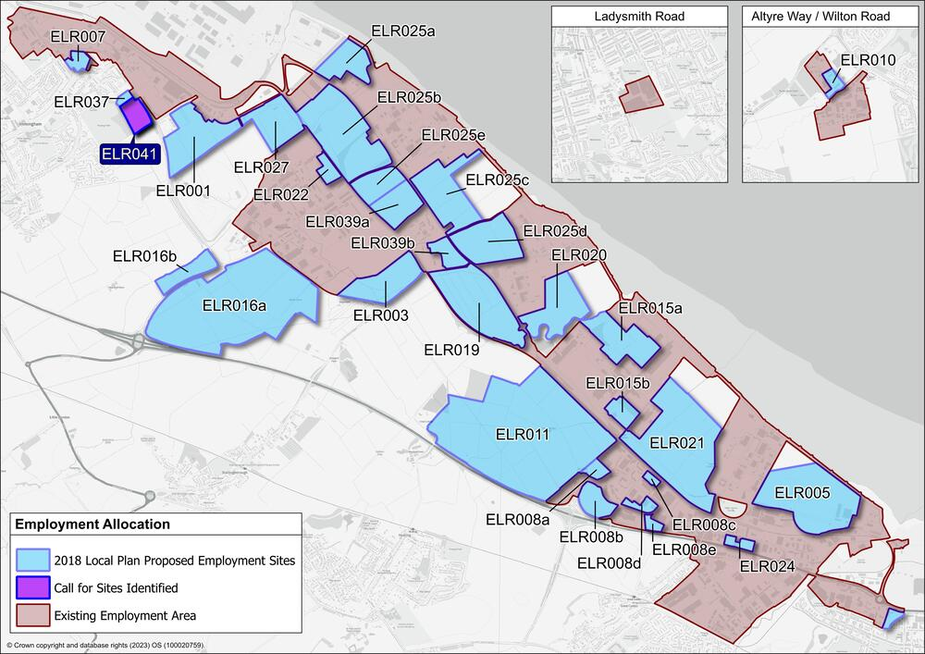
Figure 9.1 Employment sites

9.1.12 Figure 9.1 ‘Employment sites’ identifies the sites that have previously been allocated for employment development, together with a site promoted through the call for sites, each has been given a separate reference number and colour coded to reflect their current status. The Council will be looking to allocate sufficient sites to meet the future employment requirement.

Question 28

Employment allocations
Which of the land requirement options do you consider appropriate to be taken forward?

No comments to add.

Question 29

Employment allocations
Are there any sites which you consider should definitely be identified for employment development?
If so, please explain why.

No comments to add.

Question 30

Employment allocations
Are there any sites which you consider should definitely NOT be identified for employment development?
If so, please explain why.

No comments to add.

Question 31

Existing employment areas
Revision to the existing employment areas policy are proposed to include the addition of Laceby Business Park.
Do you have any comments?

No comments to add.

Question 32

Skills and training
Revisions to the skills and training policy are proposed to support local supply chains and seek local labour agreements as part of larger developments.
Do you have any comments?

No comments to add.

Question 33

Tourism and visitor economy
A minor revision to the tourism and visitor economy policy is proposed to clarify support for further visitor accommodation.
Do you have any comments?

No comments to add.

10.1.13 Set out below are a series of plans that identify possible future housing sites, these are individually referenced and coloured to indicate their status. Red sites are those under construction (identified to provide context only). Amber indicates those sites with planning permission but which are yet to commence development on site. Many of these sites are however, currently progressing. The green sites, include sites previously allocated but yet to secure planning consent, together with new sites promoted through the 'call for sites', these are sites promoted by landowners and developers and sites previously identified as deliverable. Appendix B ‘Housing site options’ provides an indication of their estimated capacity.
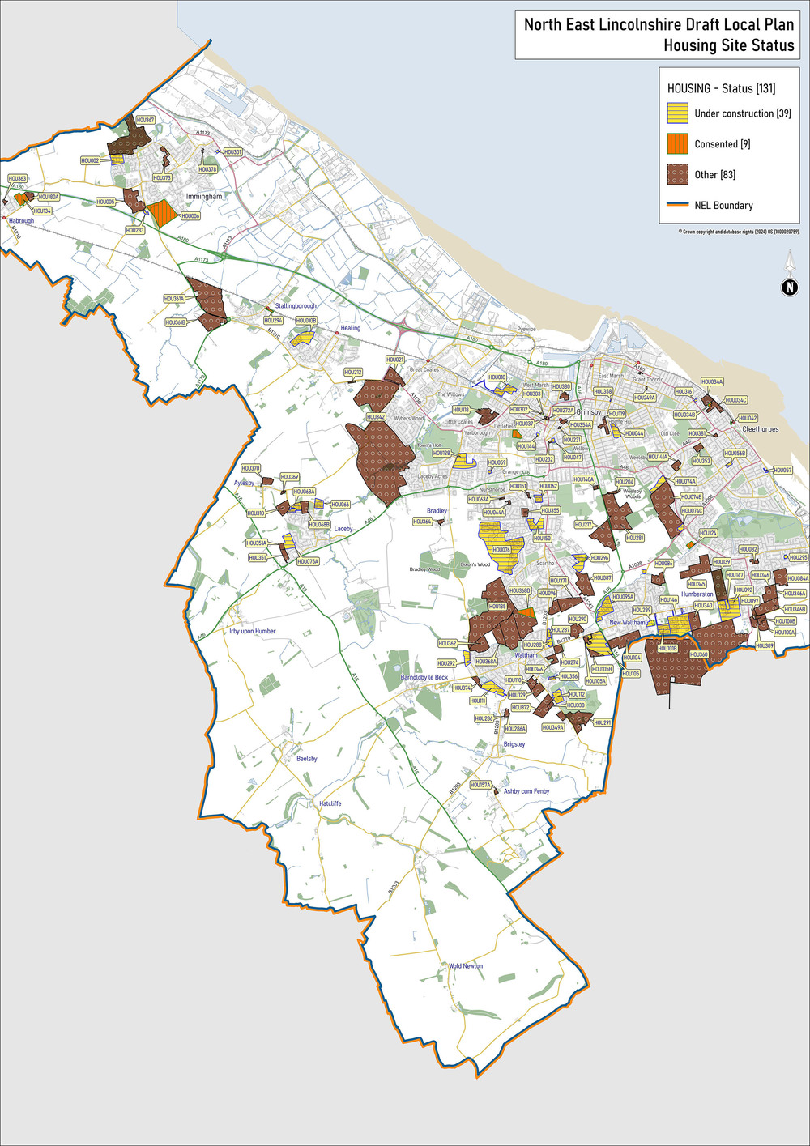
Figure 10.1 Housing sites

10.1.14 You are asked to review the sites and comment on the sites presented (quoting their individual reference number) responding to the questions set out below.

Question 34

Housing allocations
Are there any site(s) which you consider should definitely be identified for future housing, or other broad areas that should be considered for future growth?
If yes, please identify the site(s)/broad areas, and explain why.

A site that should definitely be considered for future housing and growth is the A180 corridor. With existing industrial and employment opportunities in the northern part of Grimsby and Cleethorpes, coupled with the infrastructure that is already in existence, the risk of further congestion of the A16 corridor can be minimised.

Question 35

Housing allocations
Are there any site(s) which you consider should definitely NOT be identified for future housing?
If yes, please identify the site(s) and explain why.

The site marked HOU104 on the plan lacks sufficient separation between Holton le Clay and New Waltham, which could exacerbate congestion on the A16 and diminish the green corridor separating the two villages. It is important to consider the potential impact on biodiversity and demographics of both communities, as not only will local wildlife be affected but also the quality of life for the residents of the two villages.

Draft Strategic Policy 17

Development of strategic housing sites
- Development of all strategic sites must be planned and implemented in a coordinated way linked to the timely delivery of key infrastructure. Development will be expected to:
  - create balanced sustainable communities through provision of a range of housing types, sizes and tenures, including general market, affordable housing and housing for the young and elderly;
  - ensure that local infrastructure requirements for the new community are met through provision of facilities and services (schools, community facilities, local centres, play and playing pitch provision, and healthcare) in a planned and phased manner;
  - create high standards of design that create a specific sense of place which relates well to adjoining areas, recognising and safeguarding important views and connections, and important ecological sites;
  - create safe and welcoming places which promote a strong sense of community;
  - deliver development within a framework of green infrastructure, that maximises linkage to the wider green infrastructure network, promotes healthy lifestyles, ensures rights of way are protected and enhanced, enhances the ecological value of the site through the implementation of measures to secure at least 10% biodiversity net gain, and softens development edges;
  - maximise accessibility to sustainable travel choices, promoting walking, cycling and public transport; and address necessary improvements to the highway network, both on and off-site;
  - deliver foul and surface water drainage infrastructure in a way that ties into green infrastructure provision, promotes a strong sense of place, and is co-ordinated with the phasing of the overall site;
  - minimise environmental impact safeguarding and enhancing biodiversity value, incorporating identified Local Wildlife Sites (LWS) and Sites of Nature Conservation Interest (SNCI);
  - take account of approved design guides, or other mechanisms to ensure high quality and locally distinctive design; and,
  - explore through consultation with the community, and deliver arrangements for long-term stewardship relating to drainage infrastructure, green infrastructure, open space and social infrastructure.
- The following provision must be made in the development of the strategic sites; and delivery will be secured through planning conditions and appropriate contributions:

  - prepare a masterplan for the whole site which will provide the framework for future development of the site to ensure the site is developed in a comprehensive and coordinated, manner. The Masterplan is to be agreed with the Council prior to the determination of any planning applications on the site and will form a material consideration, and the basis for determining subsequent planning applications;
  - phased development in accordance with a phasing and implementation plan included in the Masterplan, including details to secure, and phasing of delivery of:
    - education facilities,
    - open space, play and recreation provision, specifically the provision of equipped play; areas, allotments, provision and sports fields including changing and parking facilities;
    - green infrastructure, including delivery of biodiversity net gain;
    - social infrastructure;
    - affordable housing;
    - self build/custom build homes;
    - extra care and retirement homes;
    - drainage and surface water infrastructure;
    - legible and permeable, public transport, cycle and pedestrian connections throughout the development; and,
    - renewable energy and digital infrastructure.
  - develop a design guide, and deliver high quality design in accordance with the approved guide;
  - undertake a heritage impact assessment to inform the Masterplan. The heritage impact assessment will identify heritage assets including, assess their significance, and assess the impact of the development on their significance. Appropriate measure for mitigation and adding value should be identified and set out in the assessment. The heritage assessment must form the basis for approaches to the layout and design of development across the site. Planning applications for the site should accord with the heritage impact assessment; and,
  - complete, a renewable energy and digital strategy, to explore the opportunities for site-wide renewable energy generation and distribution, and digital infrastructure provision and innovation, including innovation in design and build. Where the strategy demonstrates that opportunities are technically feasible and financially viable these should be delivered as part of the development.

Question 36

Strategic sites
Do you have any comments about the wording of the strategic sites policy?

Part 4 (b) of the paragraph entitled Development of Strategic Housing Sites seems to overlook the aspect of cemetery provision. Surely a growing population will increase the demand for additional burial space.

10.3.9 The Policy wording has been revised to include detail on the affordable housing split, addressing the policy parameters and guidelines set by Government.

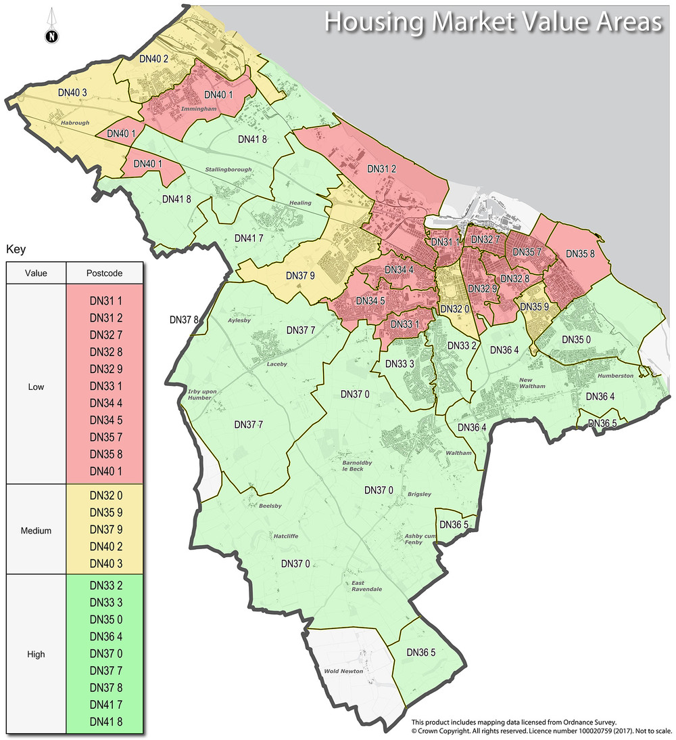

Question 37

Affordable housing
Revisions to the affordable housing policy are proposed to include detail on the split of affordable provision to be provided.
Do you have any comments?
No comments to add.

Question 38

Affordable housing
Do you consider any revision to the housing market area designations should be made?
If so please explain why.

No comments to add.

Draft Policy 7

Rural exceptions
- Exceptionally, over and above the housing supply set out in this Plan, provision for an appropriate scale and mix of affordable housing in the rural area will be permitted where the following criteria are met:
  - there is up-to-date local survey evidence of identified need for the housing proposed;
  - the development is within or adjacent to an existing development boundary as identified on the Policies Map;
  - the development is of a scale and is in keeping with the form and character of the settlement; and,
  - there are secure arrangements to ensure that all the affordable homes will be occupied by local people in need of affordable homes, and that the benefits of the low cost provision will remain affordable to local people in perpetuity.
- The Council will permit market housing to facilitate the provision of additional affordable homes only when evidence on viability supports such a stance, there is evidence that there is a need for the affordable housing proposed, and that the benefit in providing the affordable housing clearly outweighs any adverse environment impact.

Question 39

Rural exceptions
No change to the rural exceptions policy is proposed.
Do you have any comments?

No comments to add.

Question 40

Housing mix
Revisions to the housing mix policy are proposed merge the policies relating to housing mix and provision for elderly person's housing needs and housing density to form a single comprehensive policy.
Do you have any comments?

No comments to add.

Question 41

Self-build
A minor revision to the self-build and custom build policy is proposed to reflect the status and identification of strategic sites has yet to be confirmed.
Do you have any comments about the currently proposed wording?

No comments to add.

Draft Policy 10

Provision for gypsies and travellers
- In determining proposals for new sites to accommodate gypsies, travellers and travelling showpeople, consideration will be given to whether:
  - there is a proven identified need for the scale and nature of the development proposed which supports the development of, or extension to an existing gypsy, traveller or showpeople site;
  - the development is sensitive to the character and appearance of the landscape and the amenity of neighbouring properties;
  - the site has safe and satisfactory vehicular and pedestrian access;
  - there are no significant constraints to development in terms of flood risk, poor drainage, land contamination, or environmental impacts;
  - the site is suitable with regard to accessing local services and amenities; and,
  - the site can be properly serviced and supplied with essential infrastructure, including water, power, sewerage, drainage and waste disposal.
- The Council will operate a managed approach to unauthorised encampments using ‘negotiated stopping agreements’ (NSAs) whereby caravans can be directed to a suitable piece of ground for an agreed and limited period of time, with the provision of limited services such as water, waste disposal and toilets.

Question 42

Provision for gypsies and travellers
The Council has adopted a revised approach to unauthorised encampments which is reflected in revisions to the policy.
Do you have any comments?
No comments to add.

Question 43

Retail hierarchy, town, district and local centres
Significant revisions to the retail hierarchy and town centre policy are proposed, including merging policies and providing clarity on development in local centres.
Do you have any comments about the proposed revised wording?
No comments to add.

Question 44

Town centre uses
Significant revisions to the town centre uses policy are proposed, including merging policies and addressing changes to national planning policy.
Do you have any comments about the proposed revised wording?
No comments to add.

